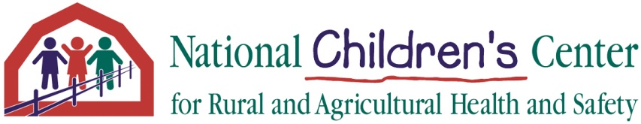

Annual Report

September 30 2017-September 29, 2018

NIOSH: 2U54 OH009568-09

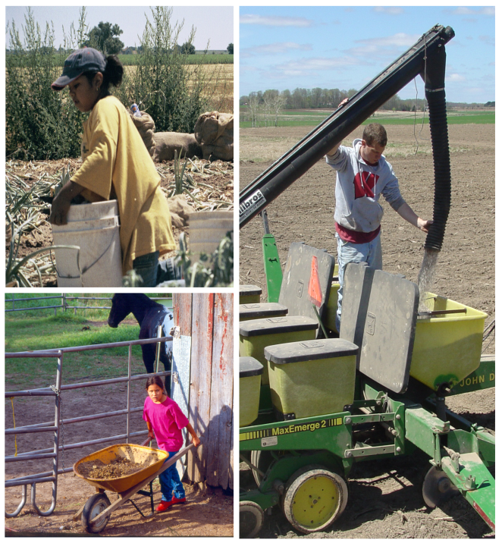

1000 N. Oak Avenue – ML1
Marshfield Clinic Research Institute
Marshfield, WI 54449

October 31, 2018

SECTION I: Center Overview

Center’s Summary
The National Children’s Center for Rural and Agricultural Health and Safety (NCCRAHS) was established in 1997 and has a long history of developing, testing and sustaining projects associated with children who live on, work on, and visit farms and ranches across the U.S. Unlike the regional National Institute for Occupational Safety and Health (NIOSH) Agricultural Centers, this Center has a national focus with a national network of partners and project collaborators. The Center’s major emphasis is on national leadership, knowledge mobilization and partnership development.

Relevance
Injury data collected by NIOSH from 1998 to 2014 revealed demographic and injury details, as well as trends over time. While overall numbers of farm injuries are declining, injuries to household youth have held steady since 2009. Injury rates for household youth 10-19 years increased in 2014 and non-working children comprised 60% of all household injuries. Hired youth and visiting youth also sustained farm injuries in 2014. Among workers <16 years, the number of worker fatalities in agriculture remains consistently higher than all non-agricultural industries combined.

The Center’s work continues to be highly relevant as we build upon scientific evidence regarding the most preventable injuries and the most effective interventions. A core issue we deal with is the “culture” of agriculture and the prevalence of injuries among hard-to-reach populations such as Anabaptist communities, children of immigrant workers, and beginning farmers and ranchers.

Administrative and Planning Core
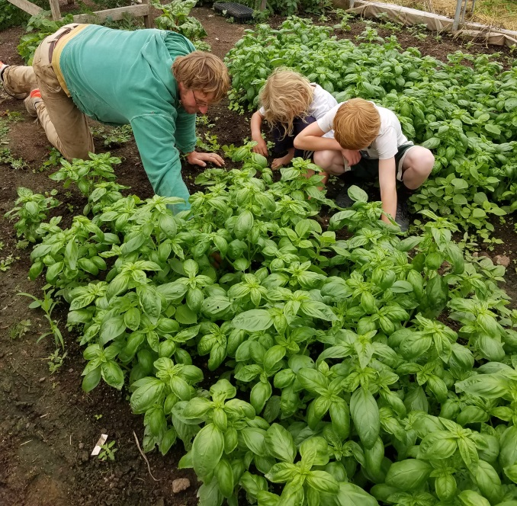
The goal for the Administrative and Planning Core is to set strategic direction and provide a framework that will support, guide, and monitor the progress of four core areas: 1) Evaluation; 2) Outreach, Education, Translation; 3) Prevention, Intervention and Translation; and 4) Research. Guidance for administrative efforts is provided at multiple levels. The Internal Advisory team includes core leaders, principal investigators and Marshfield Clinic Research Institute (MCRI) administrative leaders. The Center stays on track scientifically and theoretically via external scientific advisors linked with each project. Comprehensive evaluation is ensured by the UW-Madison evaluation team, while pragmatic recommendations come from colleagues in the Childhood Agricultural Safety Network(CASN), the Agricultural Safety and Health Council of America (ASHCA) and the NORA Agricultural, Forestry, and Fishing Sector Council. NIOSH advisors keep our activities connected with relevant NIOSH intramural and extramural endeavors.

Barbara Lee, PhD  Director  Senior Research Scientist  Phone 715-387-9182  Email | Emily Redmond, BS  Research Coordinator  Phone: 715-221-6098  Email
Barbara Marlenga, PhD  Deputy Director  Research Scientist  Phone: 715-389-3021  Email | Josie Rudolphi, PhD  Associate Research Scientist  Phone: 715-389-3794  Email
Kathrine Barnes, MS, MPH  Research Specialist  Phone: 715-221-7150  Email | Marsha Salzwedel, MS  Agricultural Youth Safety Specialist  Phone: 715-389-5226  Email
Casper Bendixsen, PhD  Associate Research Scientist  Phone: 715-387-9410  Email | Kathleen Smith  Assistant Research Manager  Phone:  Email
Scott Heiberger, BS  Health Communication Manager  Phone: 715-389-7541  Email | Bryan Weichelt, PhD  Associate Research Scientist  Phone: 715-221-7276  Email
Melissa Ploeckelman, BS  Outreach Specialist  Phone: 715-389-5387  Email | Sara Lindberg, PhD, MS  Associate Research Scientist  Phone: 608-262-6008  Email
Shelly Campo, PhD  Associate Research Scientist  Phone 319-335-9097  Email | Michael Pate, PhD  Associate Research Scientist  Phone:  Email
Linda Fetzer  Project Coordinator  Phone 814-865-4582  Email | Andrea Raygor, MS  Evaluator  Phone: 608-263-0584  Email
Amy Liebman, MA  Associate Research Scientist  Phone: 512-579-4535  Email | Diane Rohlman, PhD  Associate Research Scientist  Phone: 319-384-4007  Email

SECTION II: Highlights of Projects with High Impact

Advanced Knowledge Mobilization and E-Communication (AKME)
P.I. -- S. Heiberger, M. Ploeckelman, M. Salzwedel
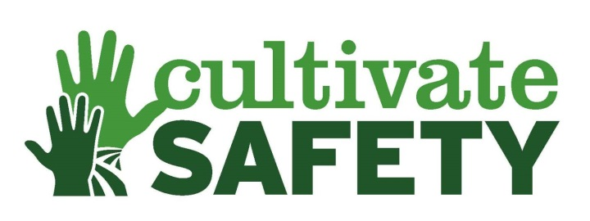
Overview and Progress: The AKME project is a centerpiece for the overall Center because the AKME health communications, marketing and technology specialists facilitate messaging, packaging and dissemination of information into, out of, and across all projects. This team collaborates with Center-wide and external partners to identify, design, utilize and evaluate appropriate communication approaches for multiple purposes. With cutting-edge technologies this project facilitates timely and culturally-appropriate communication strategies, including but not limited to, social media, virtual meetings, and mobile applications. The AKME project also serves as an incubator for building capacity by mentoring the next generation of agricultural safety and health professionals.

Outcomes and Impacts: Press releases were written in support of Center projects, leading to numerous published news reports, the most high-profile being: Reporter Jack Healy, New York Times, visited Marshfield on Jan. 10, 2018, and “5-Year-Olds Work Farm Machinery, and Injuries Follow" was published on January 29. https://www.nytimes.com/2018/01/29/us/family-farms-child-workers.html. The article sparked 356 reader comments within 24 hours, ranking it among the top New York Times articles for feedback that day. Throughout the year we continued to maintain 3 Facebook pages, 3 twitter pages, and one Instagram page totaling a following of 3,524 people. A research project was completed to measure the effectiveness of various messaging types and we found that fear-inducing messages gained the most views and engagement. Numerous presentations and posters were completed by the entire staff creating large numbers of inquiries and contacts. Finally, our Center was a sponsor for the largest farm show in Wisconsin, Farm Technology Days. We hosted the first ever Farm Safety and Rescue Area. For three days we participated and led 16 safety demonstrations a day.

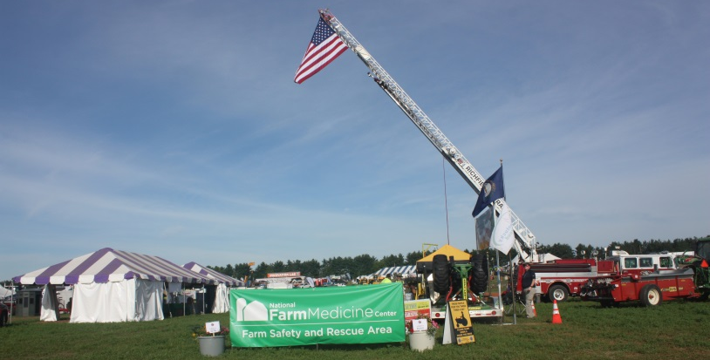
Future Research and Opportunities: As our Center continues to grow and evolve, we will continue to share our resources and expertise about child injury prevention. We have started a resource library in our Cultivate Safety webpage that will put all Center resources in one place. Our audience will be able to search, save, and order all resources in one place rather than searching multiple sites and pages.

AgInjuryNews.org P.I. – B. Weichelt

Overview and Progress: – AgInjuryNews.org is a growing collection of injury cases from publicly available reports, such as news media. This project continues to capture, store, and redistribute publicly available reports of injuries occurring in agriculture, fishing, and forestry environments. The project team gathered a great deal of input and direction from the national steering committee, which continued to guide efforts through 2018. This included several small sub-committees which advised on aspects such as injury coding schemes, crucial during the large software development project which redesigned the entire platform over the first six months of 2018.
“I am so thankful for AgInjuryNews. I wrote a story on U.S. farm deaths this year that would have been near impossible without the information available on this database. I am forever grateful!” –user feedback survey

Outcomes and Impacts: During this period, we presented our work at the International Society for Agricultural Safety and Health (ISASH) annual conference in Halifax, Nova Scotia, and at the ASHCA annual summit in Scottsdale, AZ. We published three papers in peer-reviewed journals with several others in draft or under review. One of these publications was promoted via press release and further distributed through more than a dozen media outlets across the country. Finally, we continually grew our dataset, now over 4,000 U.S. reports, and our registered user base which is now over 450, representing several hundred different organizations with an interest in agricultural health and safety, including journalists in traditional news media. Registrations are led by the Bureau of Labor Statistics, which has more users than any other organization type.

Future Research and Opportunities: In pursuing sustainability beyond the current grant period, we submitted an R01 grant proposal to the National Institute for Occupational Safety and Health in August 2018, requesting research funds to further expand the AgInjuryNews initiative, leveraging informatics-based methods to search, capture, and present data visualizations of agricultural injuries from publicly available reports. The demand for these type of data continues to grow.

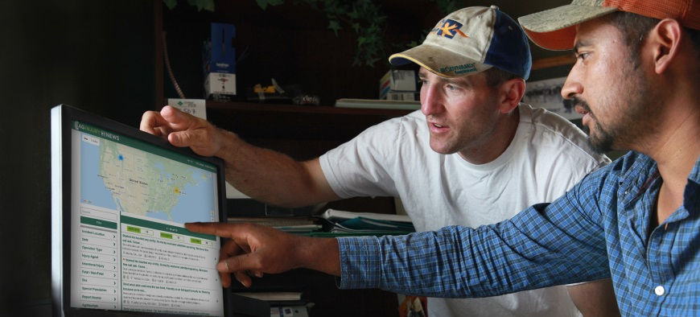

Strengthening Organizational Capacity P.I. -- B. Lee, M. Salzwedel

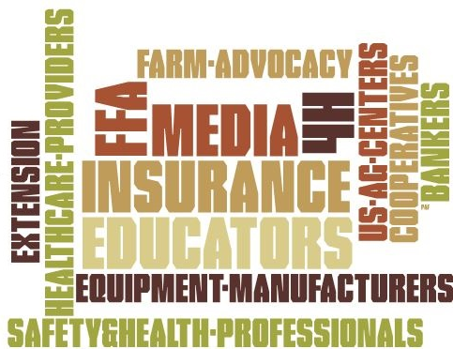
Overview and Progress: This project protects children from agricultural injury and death by working with others to share safety strategies and resources and encouraging farm families and employers to adopt them as best practices. Throughout the past year, this project has created new partnerships and strengthened existing connections with numerous organizations, taking advantage of multiple opportunities to increase our networks. Connections have been made through presentations, exhibits, resource sharing and an interactive Child Agricultural Injury Prevention (CAIP) Workshop.

Outcomes and Impacts: The CAIP Workshop was held in Marshfield, WI, on August 14-15, 2018. The participants, sponsors and staff represented various sectors of the agricultural industry including insurance, cooperatives, manufacturers, media, banking, education and safety and health. Workshop evaluation results indicated that participants found the workshop content to be engaging and useful. There has also been evidence that participants are implementing workshop content, including requests for additional resources and co-branding. Additional activities and outcomes from this project include the submission of a manuscript from the National Association of Mutual Insurance Companies (NAMIC) survey, presentations and exhibits at conferences and events, participation in external organizations’ steering committees and advisory boards, and numerous press releases, media interviews and newsletter publications.

Future Research and Opportunities: An increase in the implementation of CAIP safety strategies is anticipated as a result several $5000 grants provided through the CAIP Workshop. At least two publications are planned based on the CAIP workshop, and an invitation was accepted from a private foundation to apply for funding to assist with future CAIP Workshops.

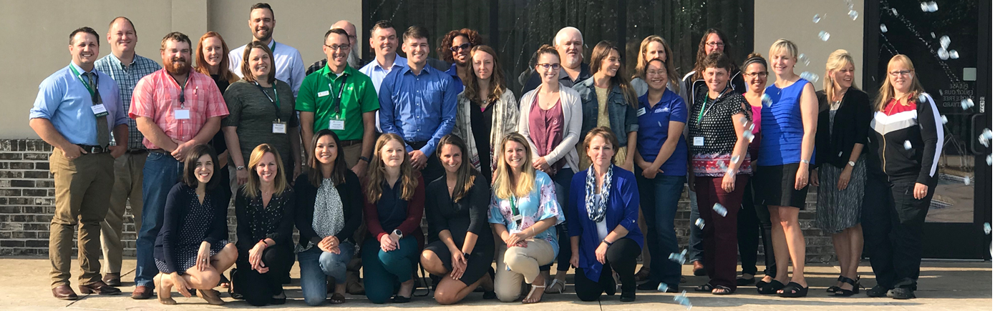
Participants and staff of the 2018 Child Agricultural Injury Prevention Workshop

Agricultural Youth Work Guidelines P.I. -- M. Salzwedel, B. Lee, S Heiberger, M. Ploeckelman
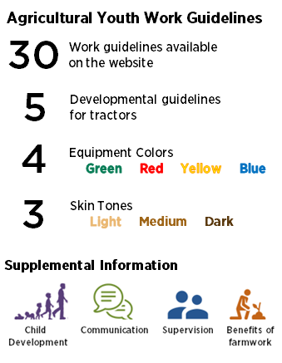
Overview and Progress: It is well known that work is good for youth, and that agriculture provides opportunities to develop work skills and gain an appreciation for the land. It is also well known that the farm worksite is dangerous, resulting in injuries and fatalities to working youth. For youth younger than 16 years of age working in agriculture, the number of fatal injuries is consistently higher than all other industries combined. These injuries and deaths are often associated with youth performing work that does not match their developmental level/abilities.

Outcomes and Impacts: The newly updated Agricultural Youth Work Guidelines can help parents and supervisors determine which tasks youth can perform safely in agriculture. There are currently guidelines updated for 30 farm tasks, with an additional 22 under development. Information on related topics, such as supervision, is also available.

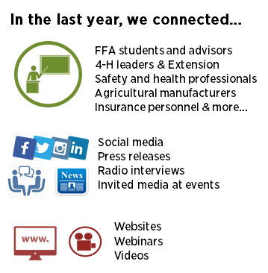
As updates to the guidelines and related materials continues, work has also been done to connect with farmers, farm supervisors and those working with farm families.

Future Research Opportunities: Additional funding was secured from CHS and the National Farm Medicine Center to finish this project. Plans for the next year include finalizing and releasing an additional 22 guidelines and translating all the guidelines into French and Spanish. Once the guidelines and translations are complete, the new versions of the guidelines will be used to update the popular Community Garden booklet and the Farm Equipment booklet. A media campaign will also be developed and implemented to launch the full set of guidelines.

Protecting Children While Parents Work P.I. – A Liebman, B. Lee, J. Simmons, M. Salzwedel

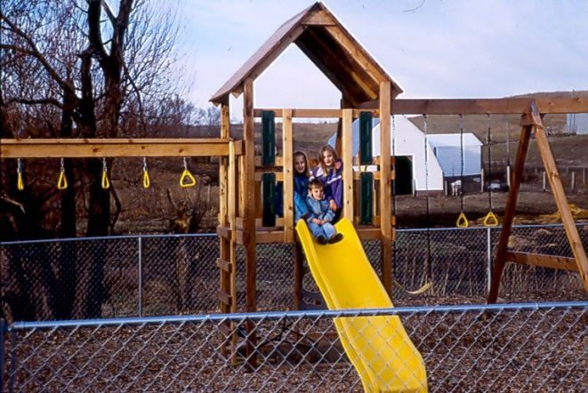
Overview and Progress: This project brings together key stakeholders, including agribusiness and childcare providers, to improve access to off-farm childcare services for migrant and immigrant agricultural workers with children. The project team gathered a great deal of input and direction from growers and child care providers through 2018. This included an in depth focus group with growers, child care providers from Migrant Head Start and representatives from agribusiness groups. The project team is finalizing a road map with step-by-step guidance to find common ground in developing child care programs in rural regions, and helping farmworker parents access a trusted source of child care while they work.

Outcomes and Impacts: During this period, we presented our work at the ISASH annual conference in Halifax, Nova Scotia, at the ASHCA annual summit in Scottsdale, AZ, at the National Council of Agricultural Employees meeting in Las Vegas, NV, and at the CAIP Workshop in Marshfield, WI.

Future Research and Opportunities: The road map will be piloted and marketed to stakeholders.

Filling the Gaps in Child Agricultural Injury Data P.I. – B. Marlenga, R. Berg, W. Pickett
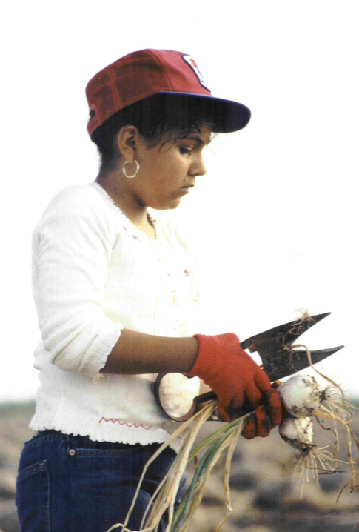
Overview and Progress: The goal of this project is to explore the most promising, existing public health data systems to determine how they can help “fill the gaps” by identifying injury events missed by other methods and/or providing more details about risks, activities and circumstances surrounding child agricultural injury events. This information, in turn, can help to guide prevention efforts. In the past year, we have made good progress in assessing the value of adapting a child health behavior survey to include location of residence (farm) and occupations, to explore individual and contextual risk factors that influence child agricultural injury. We have also made good progress in analyzing four public health data systems that are national, ongoing, injury-focused, and contain a “farm” variable.

Outcomes and Impacts: We published two manuscripts using the Health Behaviors in School-Aged Children (Canada) survey and have two more manuscripts submitted. Thus, we are showing the value of adapting a child health behavior survey to include location of residence (farm) and occupation. We have successfully collaborated with two new colleagues, a pediatric clinical psychologist and a professor of kinesiology, with these analyses. We also published a manuscript analyzing four existing U.S. public health data systems and provided recommendations for any future child agricultural injury data collection tool. The Child Agricultural Injury Fact Sheet for 2018 was updated and disseminated. It continues to be the most cited resource of the National Children’s Center.

Future Research and Opportunities: We continue to explore new avenues for child agricultural injury data. We are reviewing U.S. national youth surveys to identify any potential of adding a “farm” variable in the future. We are also exploring new technologies (e.g., machine learning) that may facilitate analyses of other large public health data sets.

Intervention through Inquiry: Understanding Beginning Farmers and Ranchers P.I. – C. Bendixsen, K. Barnes, J. Rudolphi

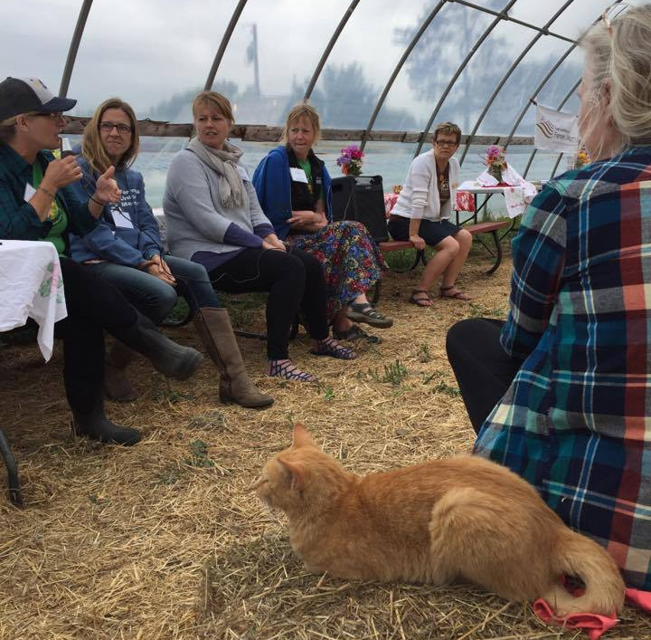
Overview and Progress: The project strives to understand the attitudes of the millennial generation and non-traditional family farmers whose livelihood has been launched by USDA-funded support. The team is comparing and contrasting demographics and practices of African Americans, Native Americans, Hispanics, and other unique groups in order to guide future culturally-relevant interventions addressing children and farm safety. Recent progress includes a survey of traditional farmers in Wisconsin and Pennsylvania as a comparison group. Additionally, tractor safety workshops were implemented for female organic beginning farmers and ranchers.

Outcomes and Impacts: Approximately 48% of surveys were returned and analysis is under way to compare parenting styles, confidence in assigning tasks and PPE, as well as injury. Preliminary results indicate 32.4% of responding households had a child that experienced an agricultural-related injury requiring medical attention beyond first aid. Additionally, knowledge learned in the project was applied to lead three female-centered tractor safety information sessions in the summer of 2018. Beginning women farmers face unique barriers to tractor procurement, with many purchasing used equipment from newspapers and the internet.
Female organic farmers giving talks to an event geared towards women breaking into organic agriculture.
As such, the women often lack safety instruction and literature that often accompanies the purchase of equipment, creating a need for tailored safety workshops. Three publications are currently under way.
Future Research and Opportunities: Work is under way with a group of former Hispanic workers transitioning into ownership is currently under way with the group’s successful mini-grant application. Results from the survey suggest continued efforts to prevent injuries on farm to children and youth should remain a priority, implementing strategies to engage with millennial parents. The tractor safety information sessions served as a trial of adapting knowledge learned to an intervention. We hope to continue to build on that knowledge to create more tailored materials and information.

SAY Clearinghouse Evaluation P.I. – D. Schaufler, M. Pate, L. Fetzer

Overview and Process: The impact of the Clearinghouse is the increased availability of ag safety and health curriculum and resources for adults that provide training to youth. The Safety in Agriculture for Youth (SAY) Project evaluation continues to make progress in examining the usage, format and satisfaction with the Clearinghouse through surveying 4-H and FFA educators in Pennsylvania and Utah.

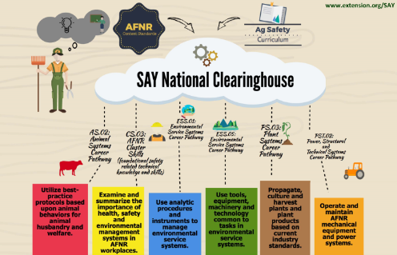
Outcomes and Impacts: The baseline survey showed that 84% of the respondents stated that the Clearinghouse is useful but that continued promotion is needed. Both surveys helped to identify gaps in the curriculum and resources available through the Clearinghouse. Survey results show that respondents receive ag safety and health curriculum primarily from professional networks, online searches, and through their employer. This information will assist in how promotion will be executed in the future. Users of the Clearinghouse like the one-stop location of resources and subject matters, but areas of improvement include updates on materials, general awareness of the Clearinghouse and increased searchability.

Future Research and Opportunities: An additional survey is planned to compare results between 4-H leaders and secondary ag educators to determine usage, satisfaction, preferred format for information, and gaps. This information will be used to develop a business model for the SAY Clearinghouse that will be used to examine new website layout options, identify ways to fill curriculum and resource gaps and recommend funding opportunities.

Enhancing Supervisors’ Skills and Employer Policies: Young Agricultural Workers P.I. – D. Rohlman, S. Campo, M. TePoel

Overview and Progress: Young workers in agriculture are injured at higher rates than in any other type of job. Researchers at the University of Iowa, funded through the Center, have developed an online training for supervisors of young agricultural workers. The training includes information for supervisors describing the health and safety risks that young workers experience because of developing minds and bodies. Based on the NIOSH Total Worker Health approach, the training focuses on both safety and health risks. Specific skills for supervisors are included in the training, for example, asking open-ended questions, methods to make sure young workers understand and can perform work tasks safely, and how to have difficult conversations with employees. In addition, the role of workplace policies in protecting young workers is described. We are currently recruiting supervisors to evaluate the training.
“I am impressed with the quality of the writing, organizational structure of the materials, and the insight of the key messaging.”
- Senior Safety
Management
Consultant

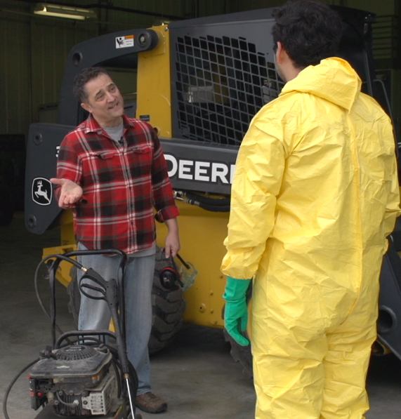
Outcomes and Impacts: During this period, we presented our work at the Midwest Rural and Agricultural Safety and Health (M-RASH) annual conference, the National Council of Agricultural Employers, and at the ASHCA summit. We also participated in the World Dairy Expo and the Childhood Agricultural Injury Prevention workshop.

Future Research and Opportunities: In the final year of this project we look forward to sharing results of the evaluation, and to make the training more widely available in multiple formats.

The online training is supplemented with videos that demonstrate training concepts.

Above, a supervisor uses the Teach Back method to train a young worker on how to operate a power washer.

Evaluation P.I. – S. Lindberg, PhD, A. Raygor, MS

Overview and Progress: The Evaluation Core guides documentation and study of NCCRAHS successes and its projects in achieving objectives for research, education and public service. The Evaluation Core continuously facilitates quarterly reporting by all projects, which includes collection of process and outcome measures. Evaluation data provide empirically-driven feedback to guide decision-making, policy formulation and improvements at NCCRAHS.
“The National Children’s Center for Rural Agricultural Health and Safety is the place that’s doing a lot of research on how to make farms safer for kids. There’s really nobody in the area that compares to that. There’s nobody in the field that even comes close.”
-2020 Vision External Key Informant Interviewee

Outcomes and Impacts: The Evaluation Core has largely focused on the 2020 Vision Project, assessing the status of the National Initiative for Childhood Agricultural Injury Prevention (NIOSH-funded and others) and working to generate and disseminate recommendations for future leadership in this field.

Between November 2017 and January 2018, the Evaluation Core conducted 31 interviews with “external key informants” who have experience and expertise in the field of childhood agricultural injury prevention. Preliminary results were presented by NCCRAHS leadership at the North American Agricultural Safety Summit in February 2018.

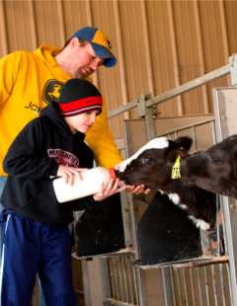
In June 2018, a further 10 interviews were conducted with internal NCCRAHS staff to incorporate their “insider” perspectives as leaders in childhood agricultural injury prevention. In September 2018, a draft of the 2020 Vision Report was shared with all 41 interviewees for their input and feedback in helping refine and finalize recommendations.

The Evaluation Core continues to support the SAY Clearinghouse in an evaluation project to understand ag educators’ awareness of the website, their perceptions of its usefulness, and their ideas for improvement. Work for this evaluation includes study design, survey development, implementation of a web-based survey, data analysis, and reporting. Results of the SAY Clearinghouse evaluation hope to inform recommendations for modification and long-term sustainability.

Future Research Opportunities: It is anticipated that results of the 2020 Vision Project will inform NCCRAHS work – and the work of other key players in the field of childhood agricultural injury prevention – into the future.

